

**RAPHA EXAMINATIONS BOARD**

e-mail: [raphaexaminationsboard@gmail.com](mailto:raphaexaminationsboard@gmail.com)

contacts: 0778710993/0740540111

**PRIMARY FIVE EXAMINATIONS 2024 (SET 3)**

**SOCIAL STUDIES**

**Time allowed: 2 hours 15 minutes**

**Pupil’s name:**

**Signature: Date**

**School name:**

**District:**

**READ THE FOLLOWING INSTRUCTIONS CAREFULLY:**

1. This paper has two sections **A** and **B**
2. All the working in both sections **A** and **B** should be shown in the spaces provided
3. All working must be done using blue or black ball point pen or fountain pen.

Diagrams **MUST** be drawn in pencil

1. Unnecessary changes of work may lead to loss of marks
2. Any handwriting that cannot be easily read may lead to loss of marks
3. Do not fill in anything indicated for *examiners use only* and those inside the paper

**For examiner’s use only**

|  |  |  |
| --- | --- | --- |
| **SECTION** | **MARKS** | **INITIALS** |
| **SECTION A** |  |  |
| **SECTION B** |  |  |
| **TOTAL** |  |  |

### SECTION A. (40 MARKS)

1. Mention Uganda’s neighbour to the North.
2. How does port Mombasa promote trade in Uganda?
3. Give the major reason why youths migrate from villages to towns.
4. Write down the commonest way of controlling soil erosion in ***Kisoro*** and

**Kabale** districts.

1. Why do people of **Bundibujo** district rear donkeys?
2. How is River Nile important to the development of industries in Uganda?
3. Mention any **one** group of people who use a compass in their daily work.
4. What is ***poaching***?
5. In which geographical region of Africa is Uganda located?
6. Why do people clear forests in Uganda?
7. How do the people of Uganda benefit from having many districts?
8. What is a ***community***?
9. Mention the title given to the political head of a district.
10. Give any **one** Island district of Uganda.
11. Name the line of latitude marked **23½ 0N**.
12. How do school children practice democracy?
13. Mention the commonest fish caught in lakes and rivers of Uganda.
14. What is ***vegetation***?
15. Why is it dangerous to settle on slopes of active volcanoes?
16. What discovery helped man to live in caves?
17. Who is the current prime minister of Uganda?
18. How does the clearing of Mabira forest affect farmers living near by?
19. Give **one** way how people destroy swamps.

## Name the map symbol below.

**P T O**

1. Why does the government encourage people to wear life jackets while travelling on water?
2. Mention any **one** condition of weather.
3. How was a bolas important to early man?
4. Why is **Pubungu** remembered in the history of Uganda?
5. State any **one** importance of large population to a country like Uganda.
6. What are ***children’s rights***?
7. How are social activities important to people in your community?
8. Which physical feature covers the largest part of Uganda?
9. Why is ***Buvuma*** called an Island district?
10. How is the formation of ***Mt Rwenzori*** similar to that of the Western arm of the rift valley?
11. Give any **one** activity carried out by farmers in the wet season.
12. Why are pedestrians advised to cross busy roads at a zebra crossing?
13. What type of coffee is commonly grown on the slopes of ***Mountain Elgon***?
14. State the importance of a school library.
15. How is ***Uganda*** related to ***Rwanda*** in terms of location?
16. Mention any **one** cause of poor performance in UPE schools in Uganda.

### SECTION B. (60 MARKS)

1. (a) Write **U.P.E** in full.
   1. Which ministry is in charge of promoting the U.P.E programme?
   2. State any **two** importance of Education.

(i)

(ii)

1. **Match correctly P T O**

## Country current president.

Uganda Samia Suluhu Hassan.

Kenya Paul Kagame.

Tanzania Yoweri Kaguta Museveni.

Rwanda William Ruto.

1. (a) What are ***social services***?
   1. Mention any **two** examples of social services.

(i)

(ii)

* 1. How is a dentist important in your country?

1. (a) Give the commonest means of communication used by people of rural areas in Uganda.
   1. State **two** reasons why most people in rural areas do not use news papers for communication.

(i)

(ii)

* 1. How is a drum used for communication?

1. (a) Mention any **two** examples of basin lakes in Uganda.

(i)

(ii)

1. How do lakes modify climate of an area?
2. What type of rain fall is received around lakes?
3. (a) What is a ***forest***?
   1. What type of wood is obtained from natural forest?
   2. Give any **two** causes of deforestation.

(i)

(ii)

1. (a) Why should road safety education be taught to school children?
   1. Mention any **two** causes of road accidents.

(i)

(ii)

* 1. How is road transport made possible a cross a river?

## (a) Name the parts of a river represented by the following.

***Main river.***

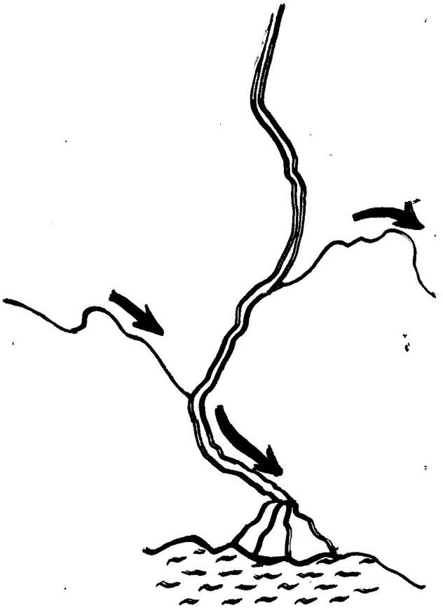

***A***

(i) **A**:

***B*** (ii) **B**:

(iii) C:

***C***

***mouth***

(b) Give any **one** importance of a river.

**P T O**

1. (a) What is ***child abuse***?
   1. Mention any **two** groups of people who protect children against child abuse.

(i)

(ii)

* 1. Why are school children encouraged to move in groups?

1. (a) What title is given to the head of the police force in Uganda?
   1. Mention any **two** departments in the police force.

(i)

(ii)

* 1. Why should the traffic officers wear uniforms while on duty?

1. (a) What is a ***swamp***?
   1. Apart from clay, give any **two** raw-materials got from a swamp.

(i)

(ii)

* 1. Mention any **one** way how swamps are misused.

1. **Use the map below to answer the following questions**.

**B D**



**A**

**MARY FIVE SST MID TERM I – REVISION PAPER 11**

1. Name the countries represented by **B** and **D**.

(i) **B**: (ii) **D**:

1. Name the main cash crop grown in area marked with letter A?
2. Name the lake which is shared by 3 East African countries.
3. (a) What is an ***ethnic group***?

**P T O**

* 1. Name the largest ethnic group in Uganda.

* 1. Mention any **two** tribes under the river lake Nilotics.

(i)

(ii)

1. (a) What are ***traditional cash crops***.
   1. Mention any **two** examples of traditional cash crops.

(i)

(ii)

* 1. Give any **one** problem faced by farmers in Uganda.

1. (a) Write a sentence about the following people.
2. ***H.E Jessica Alupo***.
3. ***Hon. Robinah Nabbanja***
4. ***Hon. Anita Annet Among***.
5. ***H.E Yoweri Kaguta Museveni***.